Sprint Plan Document

# Heading

Sprint {2} Plan

Team number: 5, Section: 47406

Team member 1: Sara al-meshrai, ID: 435202339

Team member 2: Nora Alkhunifer, ID: 435201094

Team member 3: Asmaa Alrubia, ID: 435200178

Sprint start at: 26/10/2017

Sprint competition at: 16/11/2017

# Goal

# In this sprint, we will start with integrate our work together thin implement main pages (homepage, dish page and profile page) and add authorization sections in all pages.

# Task listing, organized by user story

User story 1 “As a user, I want to see a list of dishes, so that I browse all the types shown”

Task 1 description: writing the code that reads all the dishes and their needed related data such as the shop name and its photo that are stored in the database (time estimate for task 1 is half a day)

Task 2 description: writing the code that lists the dishes and their related info to the users (time estimate for task 2 is 1 day)

Task 3 description: designing the dish list page in user friendly way so it would be easy for the user to brows it (time estimate for task 3 is half a day)

Total for user story 1: 2 days

User story 2 “As a registered/log in user, I want to able view my profile page with my avatar, name, and numbers so that I can see my profile based on my specific info and posts.”

Task 1: Design profile page elements and structure. .(2 hours)

Task 2: add “add new dish “and “sittings” buttons . .(2 hours)

Task 3: get author info and database info and organize it in page elements. .(7 hours)

Task 4: design tips list item. .(4 hours)

Task 5: implement delete and go to dish page functionality for tip item. .(6 hours)

Task 6: implement functions for displayed numbers.(4 hours)

Task 7: Code Review (2 hours)

Task 8: Test all page functionality. (3 hours)

Task 9: Acceptance testing. (3 hour)

Total for user story 2: 32 hours

User story 3 “As a user, I want to search by dish’s name, so that I save some time.”

Task 1 description: creating the search field. (2 hours)

Task 2 description: filtering the dish list based on the user input. (4 hours)

Total for user story 3: 3days

User story 4 “As register user off the app, I want to add a new dish in the app, so that added on database and dishes list for all users.”

Task 1: create form for add dish function contain name of dish, price, shop and kind of dish edit texts and labels . (4 hours)

Task 2: add the submit button and connect it with database (3 hours)

Task 3: add return options (1 hour)

Task 4: add error popup window for incorrect entered price. (2 hours)

Task 5: check there is no dish has the same information of the new dish. (7 hours)

Task 6: add “add shop “option. (5 hours)

Task 7: Code Review (2 hours)

Task 8: Test all page functionality. (3 hours)

Task 9: Acceptance testing. (3 hour)

Total for user story 4: 30 hours

User story 5 (As a user, I want to able to ' like ' mark a dish so that my favorites dishes are arranged)   
Task 1: create an empty heart icon. (1 hour)  
Task 2: fill the icon while user hovering on it. (2 hours)  
Task 3: save the heart icon as filled if the user click on it. (2 hours)  
Task 4: save the dish as liked by the user in the database. (3 hours)  
Task 5: empty the heart icon if user click on it again. (2 hours)  
Task 6: remove the dish as liked form this user in the database. (2 hours)  
Total for user story 5: 2 days

User story 6 (As a user of app, I want to view dish rating and number of raters who rate the dish.)

Task 4: connect with database. (2 hours)

Task 5: Code Review (2 hours)

Task 6: testing. (3 hours)

Total for user story 6: 13 hours

User story 7 “As a user of app, I want to view list of shop in app .”

Task 1: download the match icons and styles. (1hour)

Task 2: develop card view .(2 hours)

Task 3: implement scroll list view. (4 hours)

Task 4: connect with database. (1 hour)

Task 5: Code Review (2 hours)

Task 6: testing. (3 hours)

Task 7: Acceptance testing. (1 hour)

Total for user story 7: 14 hours

User story 8 (As a user, I want to see a list of dishes, so that I Browse all the types shown)  
Task 1 description : writing the code that reads all the dishes and their needed related data such as the shop name and its photo that are stored in the database (3 hours)  
Task 2 description : writing the code that lists the dishes and their related info to the users (6 hours)  
Task 3 description: designing the dish list page in user friendly way so it would be easy for the user to brows it (3 hours)  
Total for user story 8: 2 days

User story 9 (As a user of app, I want to rate any dish in app so that the system will add my rating on that dish)

rating base on specification (3 hours)

Task 3: Connect The rating function with database to save rating (2 hours)

Task 4: Test unit [ rating function] (2 hours)

Total hours of user story 9 :8 hours

User story 10 As a user, I want the dishes list ordered by high rating, so that I know what is the best dishes.)  
Task 1 description: adding a rate attribute to the dishes table in the database (3 hours)  
Task 2 description: By default, the dish list code will be written to order all the dishes in the database in a descending order form the heights rating to the lowest rating (3 hours)  
Total for user story 11: 1 day

User story 11 “As a developer I want to link the implemented project to ionic dashboard and link all members with it in order to make it public for all clients”

Task 1: implement needed code for link (5 hours)

Task 2: test the connection (6 hours)

Task 3: upload it to ionic viewer (1 hour)

Total for user story 12: 2 days

# Initial task assignment

Asmaa Alrubia: user story 5,6,9, all tasks

Nora Alkhunifer: user story 2,4,11, all tasks

Sara al-meshrai: user story 1,3,7,8,10 all tasks

**Initial burndown chart**

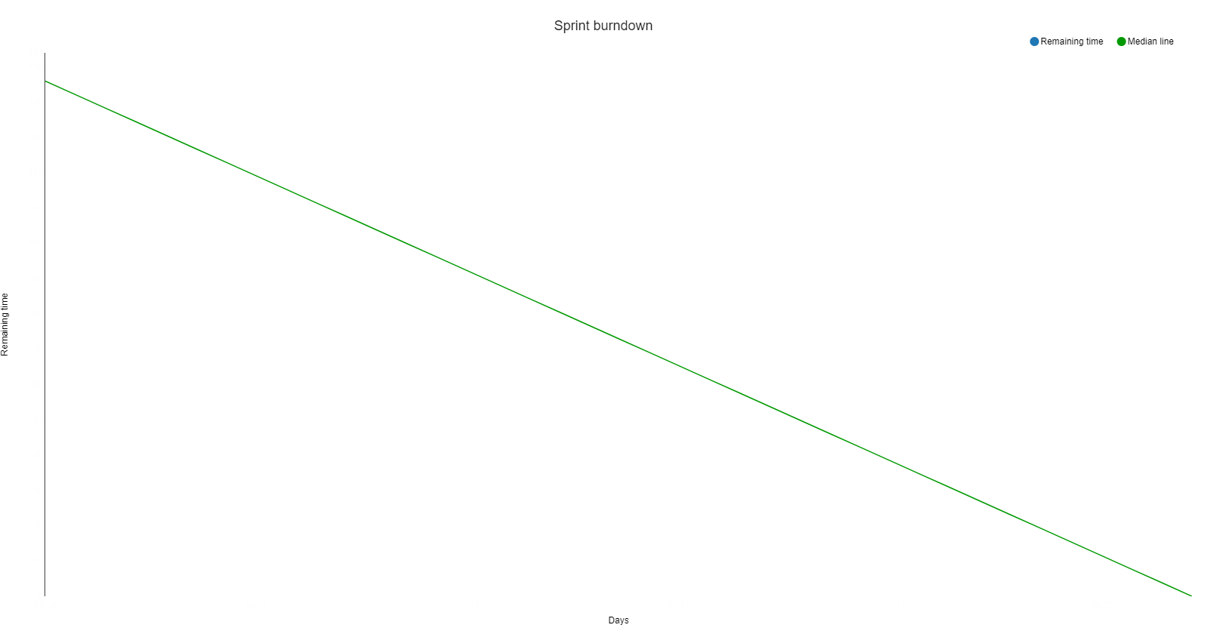

**Initial scrum board**

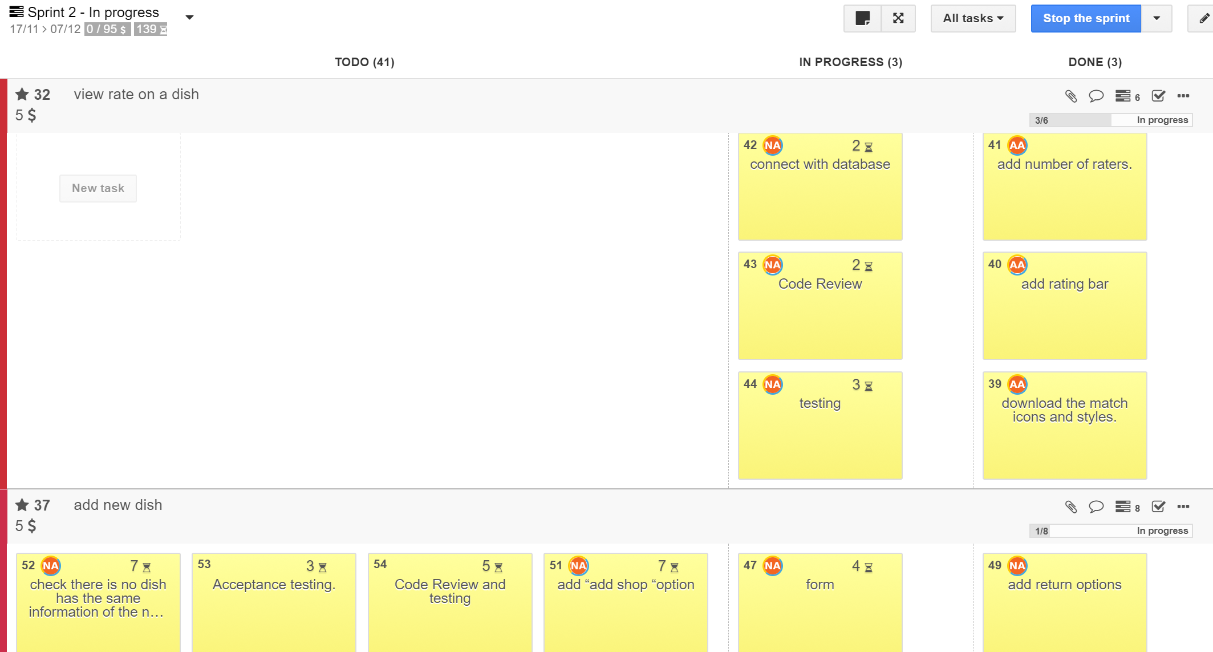

# Scrum times

Every Tue 1-3PM.

Every Thu 8-10AM.

Every Friday 8-10AM.